Supplementary Material for “Colloidal gel as an efficient process to treat CBR and prion contaminated solid surfaces”

Célia Lepeytre^{a*}, Fabien Francesª, Marie-Sophie Charvolin^{b}, Amélie Ludwigª, Esther Le Toquin^{c}, Emmanuel Comoy^{d}, Agnès Grandjeanª, Alban Gossardª

ªCEA, DES, ISEC, DMRC, Univ Montpellier, Marcoule, France
^{b}NBC-Sys, 8 rue Bonnevialle, BP 10226, 42408 Saint Chamond, France
^{c}CEA, DRF, JOLIOT, DMTS, SPI, Laboratoire Innovations Détection et Diagnostic, Marcoule, F-30207 Bagnols-sur-Cèze, France
^{d}CEA, DRF, Institut Francois Jacob, Service d’Etude des Prions et des Infections Atypiques, Fontenay aux Roses, France

*Corresponding author: C. Lepeytre
Email address: celia.lepeytre@cea.fr

Table of content
- Description of the titration method used to measure the active chlorine percentage in the CBR gels S2
- Chemical structures of the three chemical warfare agents investigated in this study S4
- Fig. SI 1. Chemical structure of (a) sulfur mustard (HD), (b) VX and (c) soman (GD). S4
- Estimation of the CBR gel density S5
- Description of the Hershel-Bulkley model S6

Description of the titration method used to measure the active chlorine percentage in the CBR gels
The active chlorine percentage was defined as the mass concentration of chlorine in the CBR gels. Samples (1 g) of CBR gel were dispersed in 10 mL of deionized water and stirred until the mixture turned light pink. Then, 20 mL of a 0.1 M potassium iodide solution and 3–5 drops of 95% H₂SO₄ were added and the solution turned brown. At this stage, potassium iodide is in excess. A 0.1 M solution of sodium thiosulfate was added dropwise and the mixture progressively became yellow. Just before equivalence, a few drops of a starch solution were added to better identify equivalence and the solution became black. Titration ended when the solution suddenly became light pink and the active chlorine percentage was calculated from the following redox equations:

ClO⁻_{(aq)} + 2H⁺_{(aq)} + 2e⁻ = Cl⁻_{(aq)} + H₂O_{(l)}
2I⁻_{(aq)} = I_{2(aq)} + 2e⁻

ClO⁻_{(aq)} + 2H⁺_{(aq)} + 2I⁻_{(aq)} = I_{2(aq)} + Cl⁻_{(aq)} + H₂O_{(l)} (1)

I_{2(aq)} + 2e⁻ = 2I⁻_{(aq)}
2S₂O₃²⁻_{(aq)} = S₄O₆²⁻_{(aq)} + 2e⁻
I_{2(aq)} + 2S₂O₃²⁻_{(aq)} = 2I⁻_{(aq)} + S₄O₆²⁻_{(aq)} (2)

The active chlorine percentage (ACP) was calculated as follows:

n(ClO⁻)_{consumed} = n(I₂)_{producted} = n(S₂O₃²⁻) / 2
[ClO⁻] × V(gel solution) = ([S₂O₃²⁻] × Veq) / 2
[ClO⁻] = 10 × ([S₂O₃²⁻] × Veq) / 2V(gel solution)

with V(gel solution) the equivalent volume of 1 g of CBR gel and the factor of 10 accounting for the dilution of 1 g of gel in 10 mL of water. The active chlorine percentage (wt. %) in the CBR gel is finally obtained as follows. The ions in the aqueous solution satisfy:

Cl_{2(aq)} + 2HO⁻_{(aq)} = ClO⁻_{(aq)} + Cl⁻_{(aq)} + H₂O_{(l)} (3)

Since n(Cl₂)_{consumed} = n(ClO⁻)_{produced} = Y mol (for 1 L of the commercial bleach solution used in the gel formula), then m(Cl₂) = M_{Cl2} × Y = 71 × Y g in 1 L of commercial bleach, with a density d_{bleach} = 1206 g.L⁻¹. The mass percentage of active chlorine in the RBC-Gel was then calculated using:

ACP (wt.%) = (71 × Y / 1206) × 100

Chemical structures of the three chemical warfare agents investigated in this study
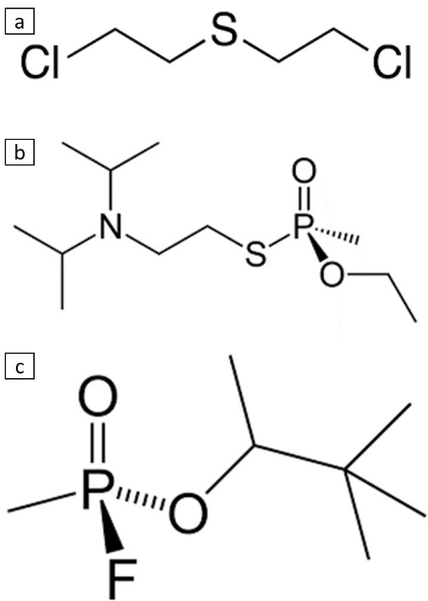
Fig. SI 1. Chemical structure of (a) sulfur mustard (HD), (b) VX and (c) soman (GD).

Estimation of the CBR gel density
To determine the approximate CBR gel density, we consider a colloidal suspension of Aeroxide Alu C alumina in pure water and disregard the presence of NaOH, Pluronic PE 6200, iron oxide and hypochlorite ions.
The density of the Aeroxide Alu C alumina (d_{Alumina}) is given by the Safety Data Sheet of the product at 3.27 g.cm⁻³.
The density of the gel is calculated as followed :
$$ρ_{gel}=\frac{m_{H_{2}O}+m_{Alumina}}{V_{H_{2}O}+\frac{m_{Alumina}}{d_{Alumina}}}$$
Using this equation, the approximate density of the CBR gel is determined at 1.11 g.cm⁻³

Description of the Hershel-Bulkley model
The Hershel-Bulkley model describes the behavior of non-Newtonian yield stress fluids. This model accurately describes the rheological behavior of large range of colloidal gels. The Hershel-Bulkley model is expressed as follows:
$$τ= τ_{y}+K{\dot{γ}}^{n}$$
with τ, the shear stress applied to the gel, τ_{y}, the yield stress of the gel, K, the consistency, a proportionality constant that depends on the structure of the gel, and n, the flow index which reflects the degree of deviation from Newtonian behavior. The fluid behaves as a solid for τ < τ_{y} and as a liquid for τ > τ_{y}. If n < 1, the fluid is shear thinning and if n > 1, the fluid is shear thickening.

